# **Ansible Automation Platform (AAP) Templates Testcases**

This documentation describes all templates that are put on the AAP, and how to verify they work correctly on Azure. Following sections are organized by purpose of operations. Related templates are arranged together.

Notice: The AAP should be login through the personal account (abb email) not the Azure account。

## **Testcases**

### Azure_create_RG

This template is used for creating a resource group, and it runs the ‘create-resource-group.yml’ playbook. This template creates a resource group, named ‘ResourceGroupAAPtest2024’ in Azure with the location EastUS. The result can be checked in Azure Resource groups.

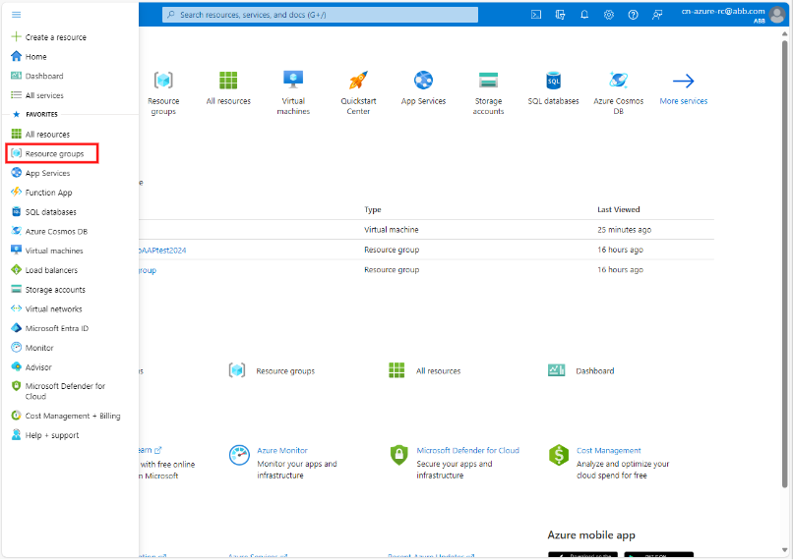

The origin state is shown below,

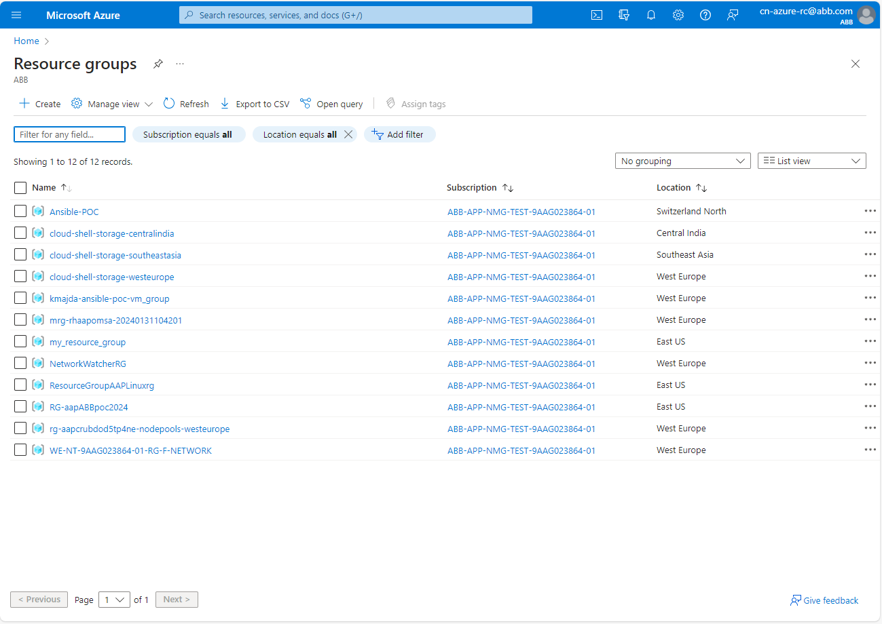

Then, in AAP > Templates, and find ’Azure_create_RG’,



Click the ‘Rocket’ Button to run the template. The AAP will automatically jump to the Jobs Output page, and if template run successfully, a green ‘Successful’ would be displayed next to the template name, as shown below,

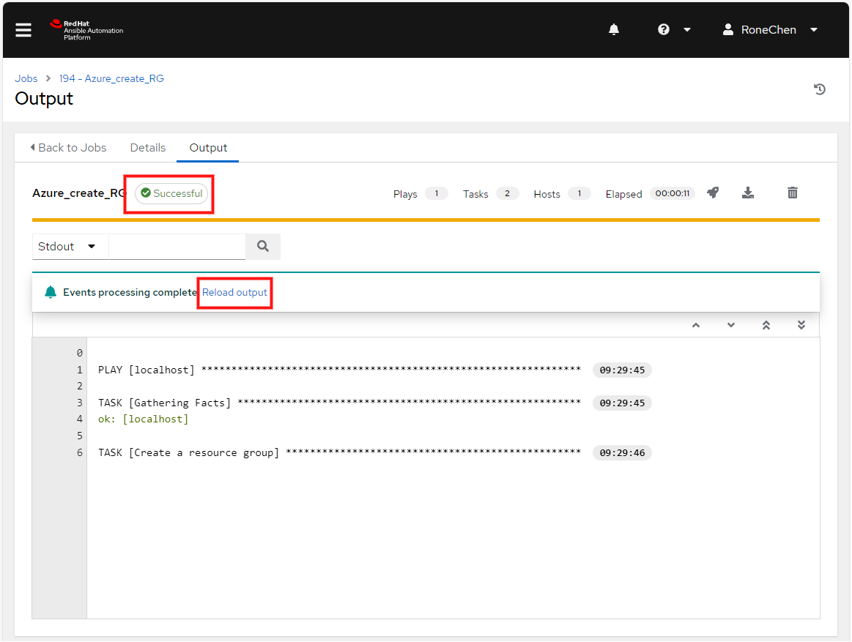

Click the ‘Reload output’ button to refresh the output message.

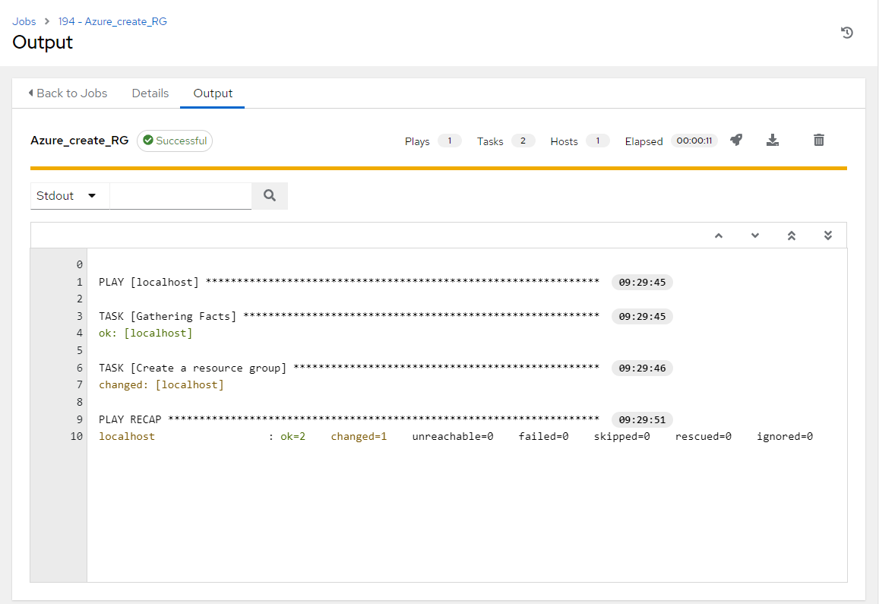

Check the result on Azure > Resource group. A new resource group, called ‘ResourceGroupAAPtest2024’ should be listed, otherwise, click the ‘Refresh’ button on the top of the list.

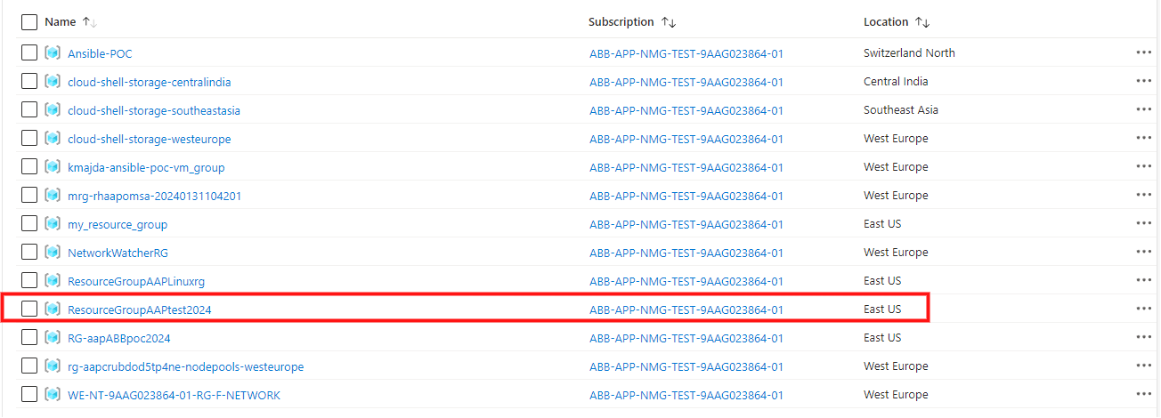

We can find the resource group, called ‘ResourceGroupAAPtest2024’, is created successfully, and the location is East US.

### Azure_create_Linux_VM

This template is used for creating a Linux virtual machine on Azure and runs ‘create-linux-VM.yml’ playbook. This template includes:

1. Create a resource group, called ‘ResourceGroupAAPLinuxrg, with location EastUS.
2. Create a virtual network, myVnet, and the address prefix is 10.0.0.0/16.
3. Add a subnet, the address prefix is 10.0.1.0/24, and is called myVnet.
4. Create public IP address and it should be static, which is called myPublicIP.
5. Create a network security group that allows SSH. The name of the security group is myNetworkSecurityGroup with rules Tcp protocol, 22 destination port. And the priority is set to 1001 with Inbound direction.
6. Create a virtual network interface card. The name is myNIC, and the virtual network is set as myVnet. The subnet is set to mySubnet, and the public Ip name is myPublicIP.
7. Create a virtual machine. The size of the machine is Standard_DS1_v2, and the username and the password are azureuser and P@ssw0rd12345 repectively. The OS is CentOS, and sku = 7.5.

After clicking the ‘rocket’ button to run the ‘Azure_create_Linux_VM’ template, Linux VM creation on Azure is launched. The output message can be checked in the ‘Output’ paged as mentioned above and click the ‘Reload output’ to refresh the message.

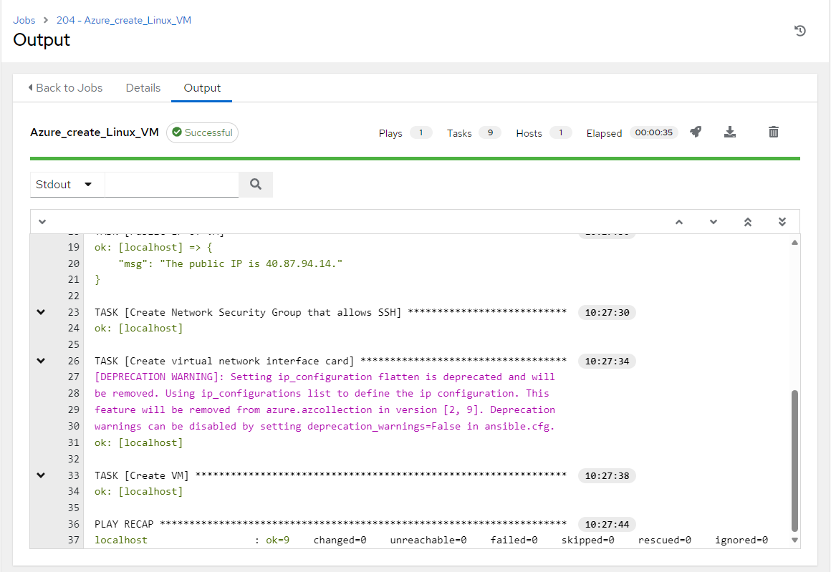

If the template ran successfully, a resource group, named ‘ResourceGroupAAPLinuxrg’, is created, and can be checked on Azure under Home > Resource groups. Click the resource group can check its network security group, virtual network interface card, public IP address, the virtual machine and virtual network configuration.

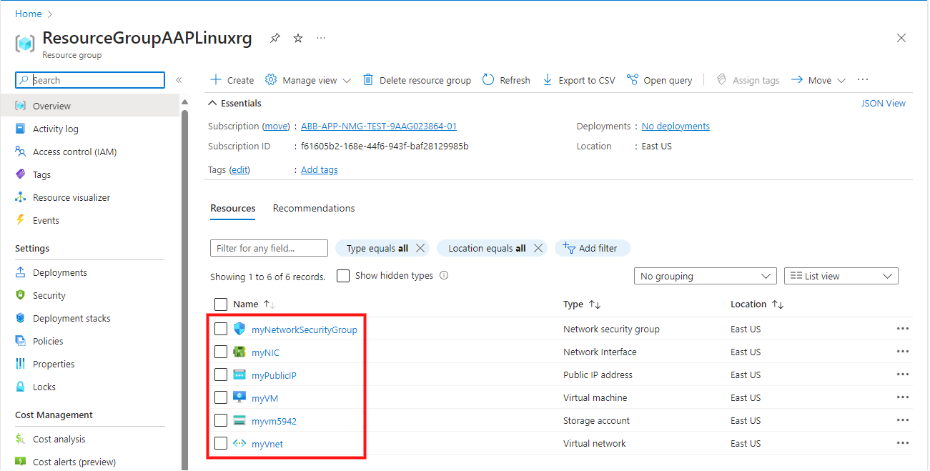

To check the subnet configuration, click the ‘myNIC’, and check the Network interface item,

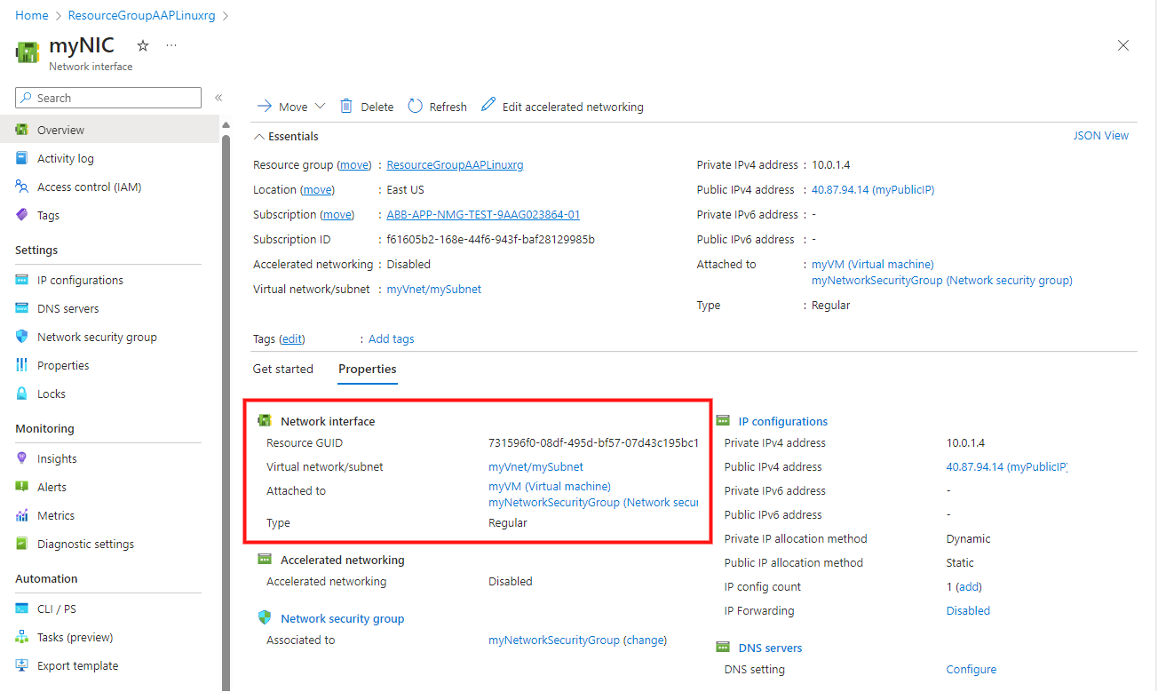

### Azure_change_linux_VM_size

This template is used for changing the size of Linux virtual machine and runs the ‘change-linux-VM-size.yml’ playbook.

After the Linux VM creation, the default size is Standard DS v2 (1 vcpu, 3.5 GiB memory), the information can be verified by clicking ‘myVM’.

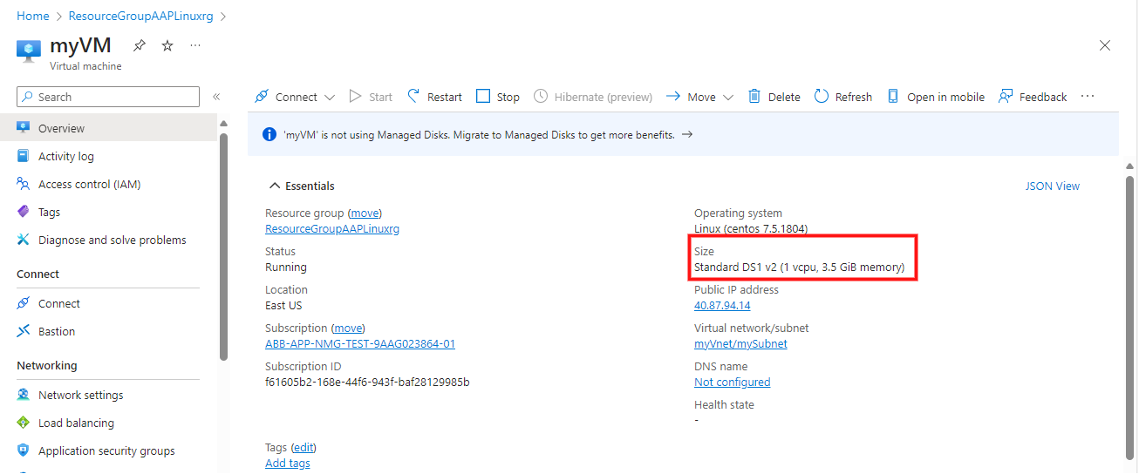

To run the Azure_change_linux_VM_size template, click the ‘rocket’ button. If the template ran successfully, the size information would be Standard DS2 v2 (1 vcpu, 3.5 GiB memory).

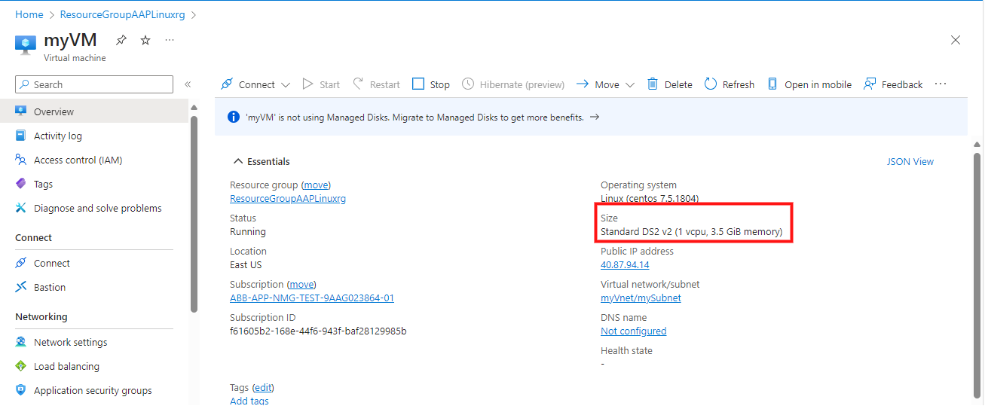

### Azure_stop_linux_VM

This template is used for stopping a Linux virtual machine. It runs the ‘Stop-linux-VM.yml’ playbook. Before running the template, the status of ‘myVM’ is ‘Running’,

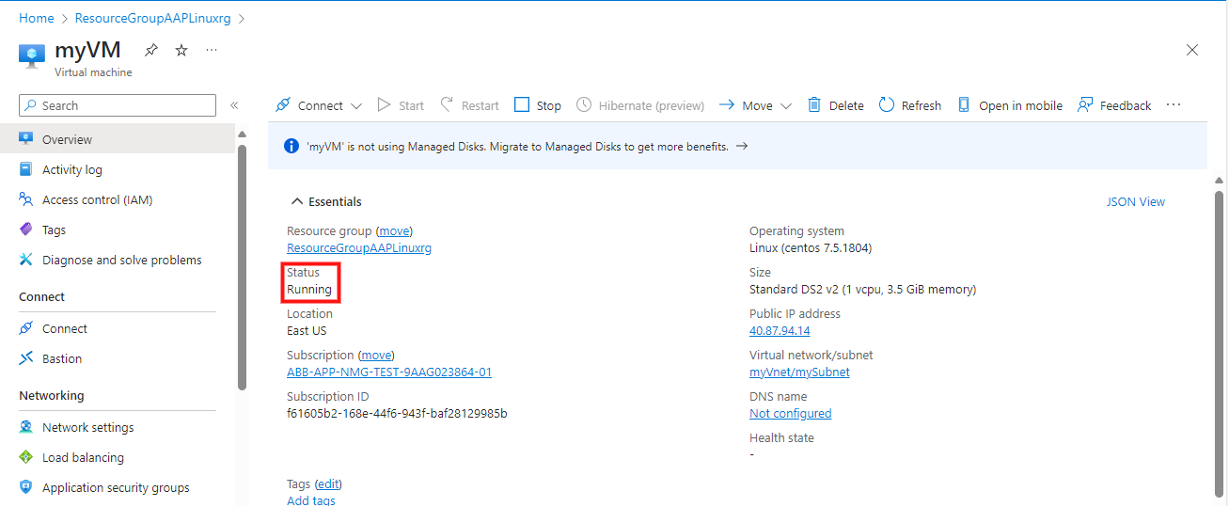

After running the template, the status of ‘myVM’ is changed to ‘Stopped’,

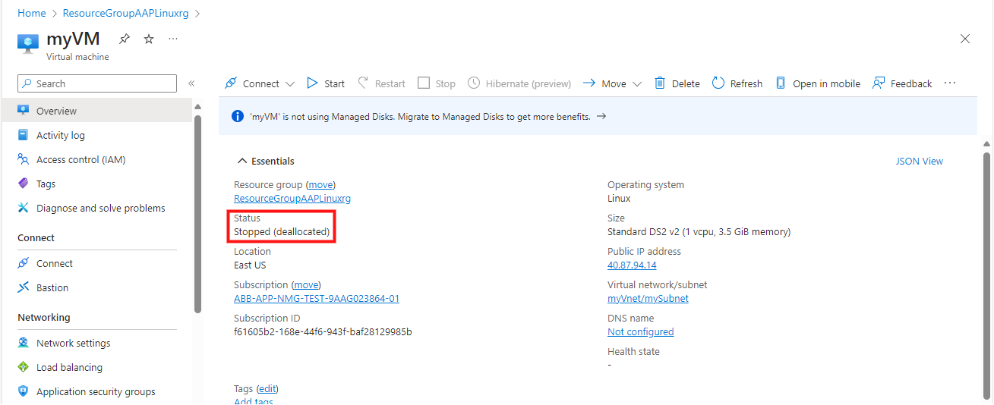

If the status doesn’t change, you should click the refresh button.

### Azure_start_linux_VM

This template is used for starting a Linux virtual machine, and it runs the ‘start-linux-VM.yml’ playbook. After running the template, the status of ‘myVM’ is changed to ‘Running’,



### Azure_remove_RG

This template is used for remote a resource group, and it runs the ’delete-resource-group.yml’. After launching the template, AAP will ask for the name of a resource group,

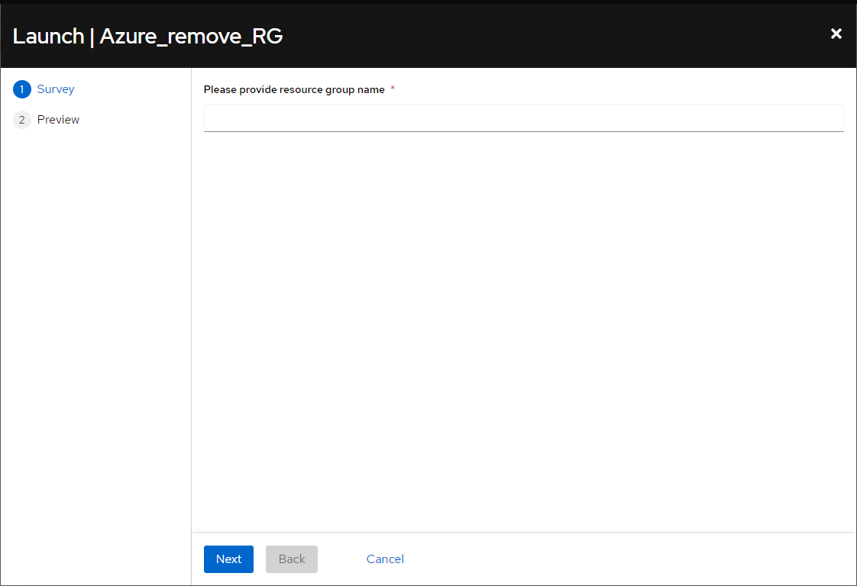

The user should enter the name of the resource group he/she want to remove, and then click ‘Next’. For example, we use ‘ResourceGroupAAPLinuxrg’, and the input resource group name will be displayed under ‘Variables’.

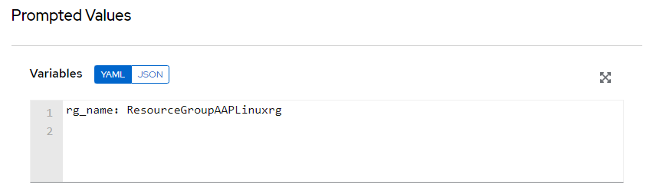

Click the ‘Launch’ button to run the template, and it will take about 3-4 minutes. After it finished, the resource group is removed on Azure. The result can be checked in the Resource groups list,

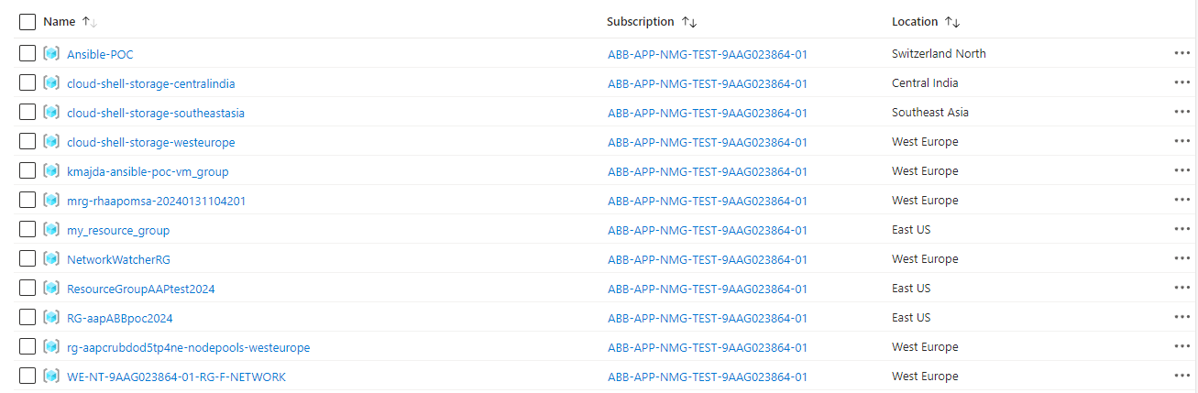

### Azure_create_mysql_DB

This templated is used for creating a MySQL server and create an instance of MySQL dataset. It runs ‘create-mysql-database.yml’ playbook. The default resource group is named ‘ResourceGroupAAPtest2024’, which can be found in the ‘Resource groups.’ Notice: this template does not contain resource group creation. In the beginning, the resource group is empty,

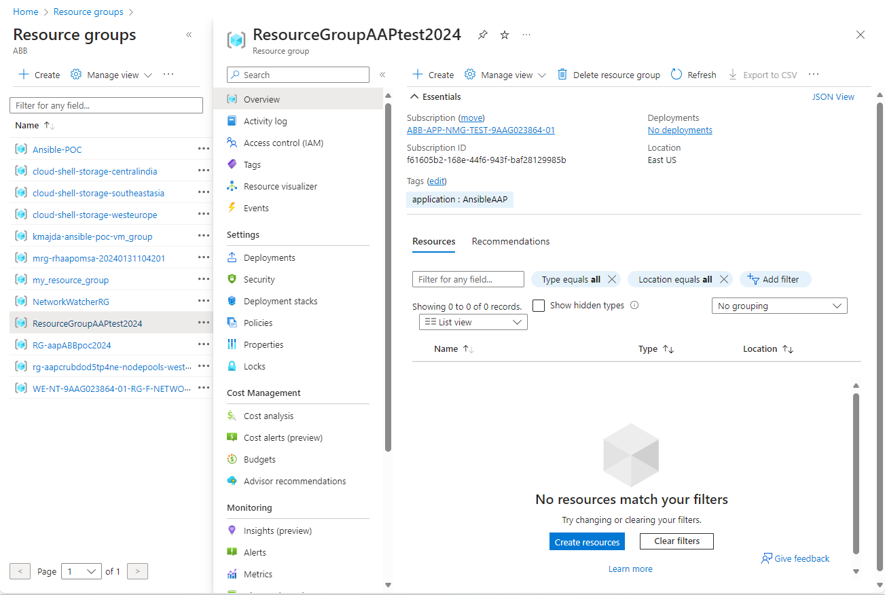

After launching the template, an’ Azure Database for MySQL single server’ named ‘’ can be found in the ‘ResourceGroupAAPtest2024.’

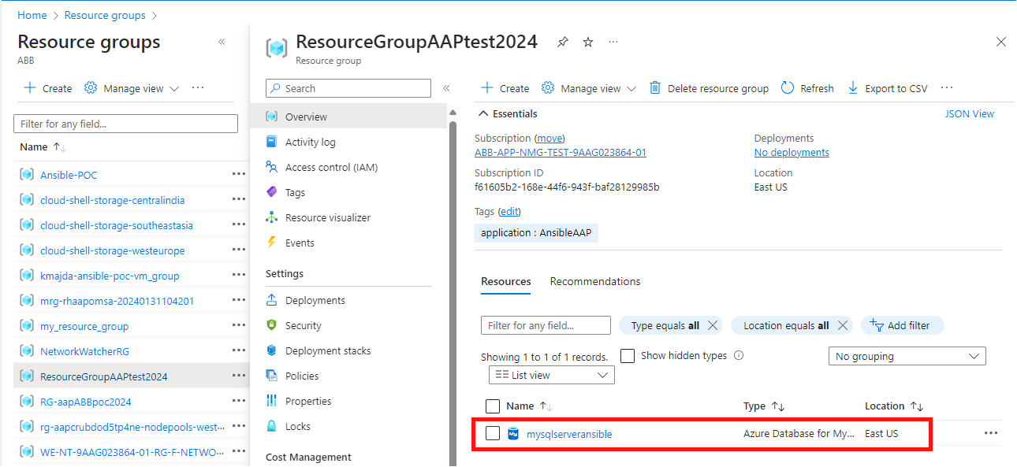

Click the item of the database, status, location, server name, and server admin login name can be found on the top,

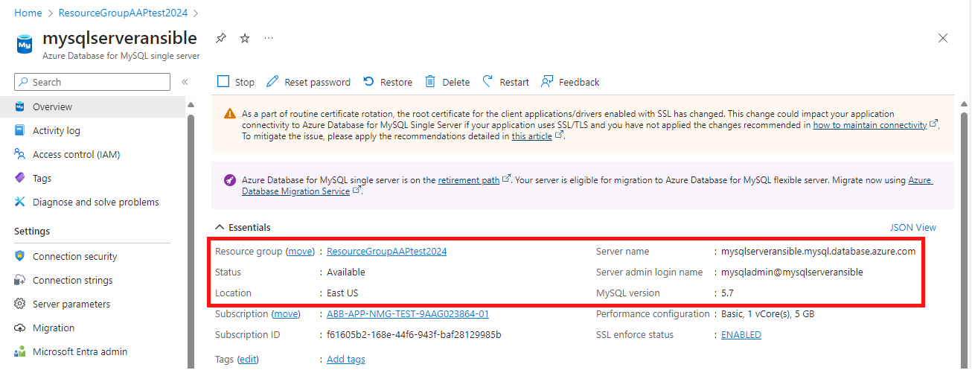

Database and other resource can be found at the bottom.

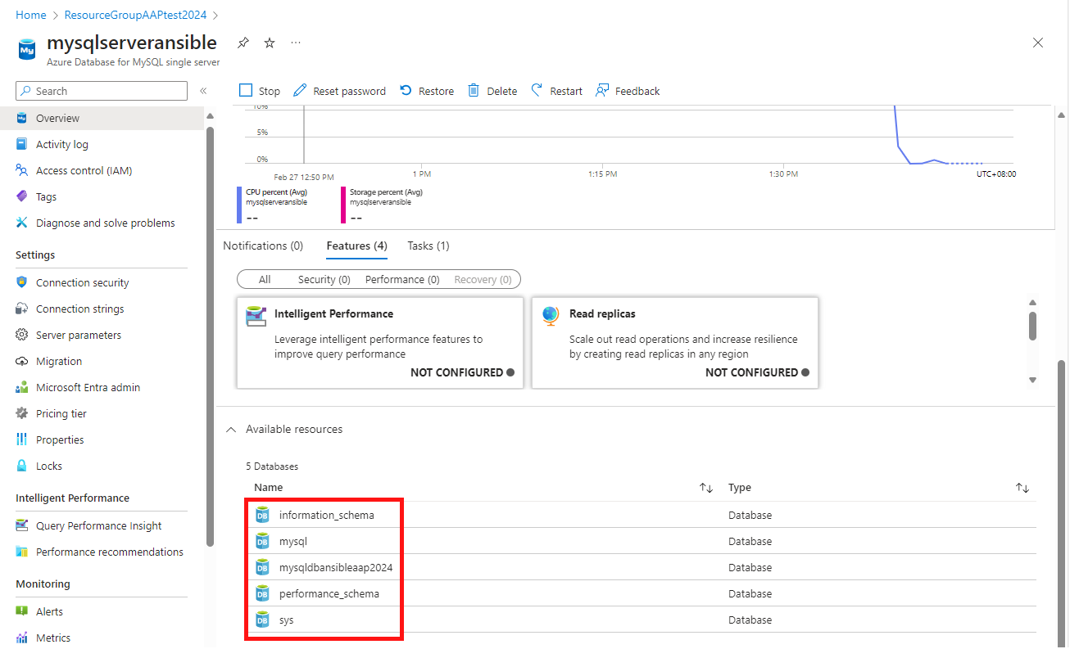

### Azure_create_storage

This template is used for creating an Azure storage account, and it runs ‘cloud_storage_create.yml’ playbook. This template will create a resource group, called ‘my_resource_group’, at first. And then create a ‘storageacctaap2024’ storage account in the resource group. The location and account type can be checked after clicking the item in the resource group,

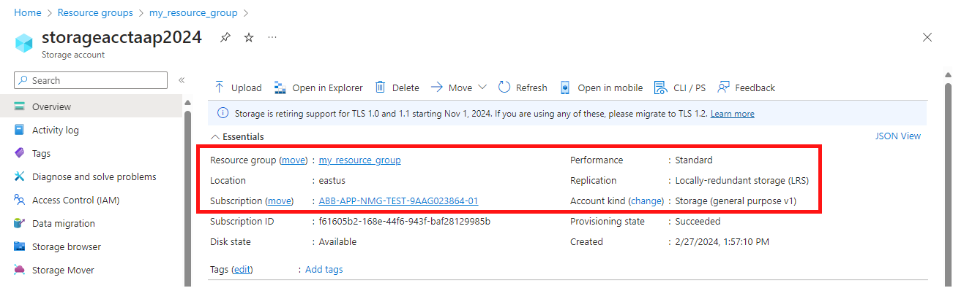

### Azure_remove_storage

This template is used for removing an Azure storage account, and it runs ‘could_storage_remove.yml’ playbook. Currently, this template will remove a storage account, named ’storageacctaap2024’ in ‘my_resource_group’ resource group. Having run the template, the above storage account cannot be accessed,

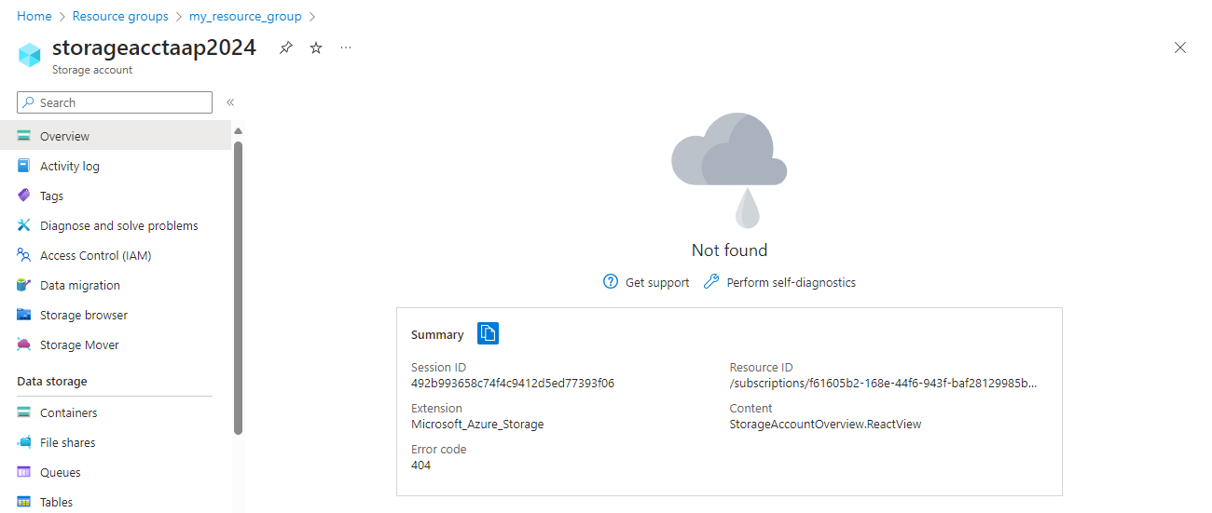

### Azure_create_Windows_VM

This template is used for creating a Windows virtual machine on Azure, and it runs the ‘create-windows-VM.yml’ playbook. The template includes:

1. Create a resource group, which is called ‘ResourceGroupAAPwindowsrg’.
2. Create a virtual network named vNet with address prefix ’10.1.0.0/16’.
3. Add a subnet with address prefix ’10.1.1.0/24’.
4. Create a public IP address, ‘pip’.
5. Create a network security group, ‘networkSecurityGroup’.
6. Create a network interface, ‘nic’.
7. Create a Windows virtual machine/ the size of the virtual machine is ‘Standard_DS1_v2’ and the network interface is as the above mentioned ‘nic’.

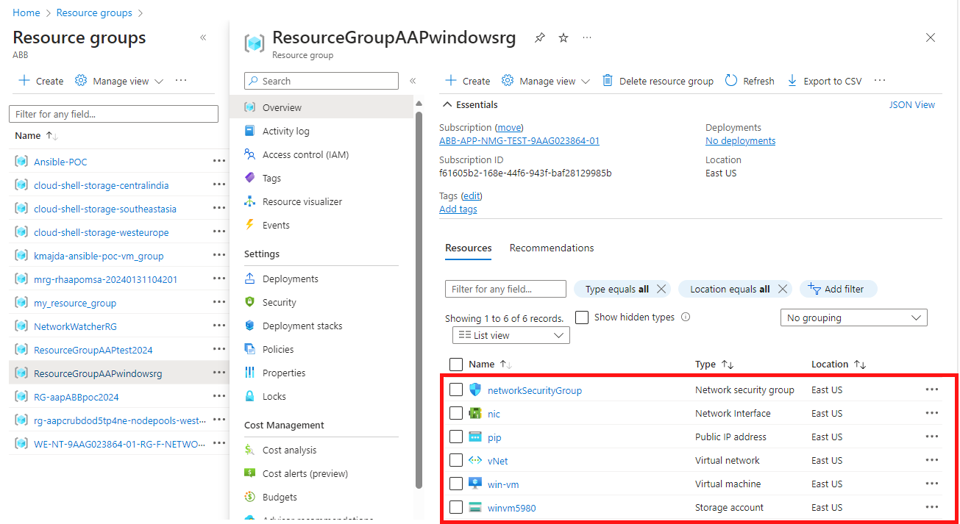

More properties can be checked by clicking these items.

### Azure_update_tag_RG

This template is used for creating a resource group with tags, and it runs the ‘update-tag-resource-group.yml’ playbook. This template will create a ‘ResourceGroupAAPtest2024’ resource group with tags: {application: “AnsibleAAP2024”, applicationID: “123456789”}. The result can be checked by clicking the resource group.

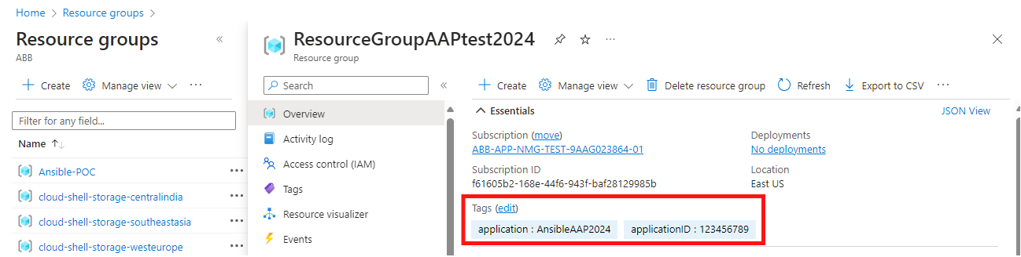

### Azure_remove_tag_RG

This template is used for removing all tags of a resource group, and it runs the ‘remove-tags-resource-group.yml’ playbook.

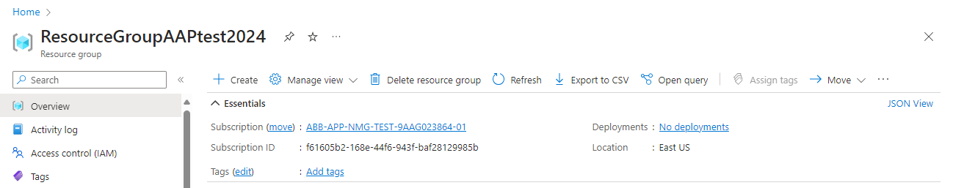

The result can be checked at the same place as the above template.